Final Report

Real Time Bus Tracking App

University Of British Columbia Okanagan

COSC 499

# Table of Contents

**Table of Contents** **3**

**Identification** **7**

Project Stakeholders 7

Team 8

Authors 9

Document History 9

**Terminology** **10**

**Scope and Charter** **11**

Document History 11

Project Purpose 11

Project Objectives 12

Project Description 12

Success Criteria 12

Out of Scope 13

Functional Requirements 13

Incomplete Functional Requirements 14

Non-Functional Requirements 14

Development 14

Performance 15

Incomplete Non-Functional Requirements 15

Technical Requirements 15

User Requirements 16

User Groups 16

Assumptions 16

Environmental Constraints 17

Risks 18

Project Development Methodology 19

Project Milestones 19

Use-Case Index 20

Use Cases 21

Use-Case diagram 28

Technical Specifications 29

Client Side: 30

Server Side: 30

**Work Breakdown** **31**

Work Breakdown Structure 31

Burndown Chart 35

Team Hours 36

Matthew De Leeuw 36

Kyle Rennie 36

Trevor Gallicano 36

Wasek Habib 36

Ini Oladosu 36

**Current Implementation** **37**

Test Report 37

User Test Results 41

Q1: I am satisfied with the look and feel of the app. 41

Q2: The bus location updates in an appropriate time. 42

Q3: The interface is responsive to my actions. 42

Q4: All the features are necessary and useful. 43

Q5: I would recommend this app to a friend or colleague. 43

Q6: Are there any additional features you would like to see added to the app? 44

User Testing Summary 44

**Design and Testing** **45**

Usage Scenarios 47

User Groups 47

Actors 47

System Architecture Diagrams 48

Software Architecture 48

State Diagram 49

NoSQL Data Model 49

User Sequence Diagram 50

UI Mockup 51

Detailed Test Plan 52

Test Scope 52

Functional Scope 52

Non-Functional Scope 54

Out of Scope and Exclusions 55

Test Schedule 56

Negative Unit Test 57

Positive Unit Test 57

Positive Integration Test 57

Positive System Test 57

Negative System Test 57

Regression Test 57

User Test 58

Positive Stress Test 58

API Test 58

Test Data 58

Test Environment 58

**Future of Project and Summary** **59**

Environment Description 59

Workflow 59

Testing 59

Deployment 59

Known Bugs 60

Key Lessons Learned 60

User Manual 61

System Overview 61

System Configuration 61

User-Access Levels 61

Contingencies 61

Getting Started 61

The Bottom Black Bar 61

Navigation Button 62

Notification Button 62

Cancel Tracking Button 62

Android Button Bar 62

App Icon 62

Using the System 63

Reporting 63

Report Capabilities 63

Report Procedure 63

Application Installation Guide 64

Server-side Installation and Deployment Guide 65

Unfinished Testing 65

Core Requirements Delivered 65

Unimplemented Features 66

Resources 66

GitHub Repository 66

API Documentation 66

MongoDB 66

Firebase Server 67

AWS Backend Server 67

AWS Jenkins Server 67

IBM Connect Test and Monitor 67

**Approval** **68**

# Identification

Name of Project: Bus Tracking App

Sponsor: Fremtid Media

## Project Stakeholders

|  |  |
| --- | --- |
| Stakeholder Names | Roles |
| Fremtid Media | Sponsor/Client |
| Reza Afzali | Client |
| Simranpal Bains | Client |
| Scott Fazackerley | Instructor/Supervisor |
| UBCO Students/ Residents of Kelowna | Users |
| COSC Capstone Team 12 | Android App Developers |
| Engineering Capstone Team | Hardware/Infrastructure Team |
| University of British Columbia | Academic Institution |
| Kontakt.io | Beacon Provider |
| Google | Android OS Provider |
| Here | Maps API Provider for Showing Bus Location on the App |

## Team

|  |  |  |
| --- | --- | --- |
| Team Members | Roles | Responsibilities |
| Wasek Habib | Product Manager | * Primarily responsible for the project workflow, requirements engineering, software architecture, and ensuring SDLC. * Involved in design and development process. |
| Ini Oladosu | Technical Lead | * Responsible for the non coding documents * Responsible for UI Design of application * Involved in development process |
| Matthew De Leeuw | Integration Lead | * Responsible for checking code before integration into master branch (aka) responsible for what gets deployed * Responsible for programming with team on seperate features |
| Trevor Gallicano | DevOps Lead | * Responsible for continuous integration/deployment * Responsible for automated testing * Involved in development process |
| Kyle Rennie | Client Liaison | * Responsible for continuous client contact and logging conversation * Involved in development process |

## Authors

|  |  |
| --- | --- |
| Document Owner(s) | Contact |
| Wasek Habib | wasek.edu@gmail.com |
| Matthew De Leeuw | mattdeleeuw@hotmail.com |
| Trevor Gallicano | trevorg@hotmail.ca |
| Ini Oladosu | inioladosu@gmail.com |
| Kyle Rennie | kyrenzie@gmail.com |

## Document History

|  |  |  |
| --- | --- | --- |
| Version | Date | Document Revision Description |
| 1.0 | April 14, 2019 | Initial document |

# Terminology

|  |  |
| --- | --- |
| Item | Description |
| Beacon | A low-energy Bluetooth device used to determine a device’s location. Developed by Kontakt.io |
| Continuous Integration (CI) | Development strategy used to automate integration, testing, and deployment. |
| Espresso | Java based testing API used to test UI of Android applications |
| Integration Test | A test that verifies interfaces (interactions) between two or more modules. |
| Module | A specific function or piece of the software system. |
| System Test | A test that verifies functionality of the completed system. |
| Test-Driven Design (TDD) | Design strategy that has tests created before development of a module. |
| Unit Test | A test that verifies the functionality of the smallest unit of code. The smallest unit will be referred to as a module. |
| User Interface (UI) | The graphical layer which allows the user to interact with the software system. |
| REST API | (Application Programming Interface): Tool that helps to communicate between two programs using HTTP protocols. |

# Scope and Charter

## Document History

|  |  |  |
| --- | --- | --- |
| Version | Date | Document Revision Description |
| 1.0 | October 23, 2018 | Initial document |
| 2.0 | November 20, 2018 | Updated to match changes |
| 3.0 | December 5, 2018 | Changes to requirements |
| 4.0 | April 16, 2018 | Revision for final report |

## Project Purpose

Currently there is a ridership of 4.9 million in Kelowna per year, a fair amount of riders (>1%) use the transit app, with this app we are looking to take a portion of the demand for maps and transit for this app. Current apps have issues with telling the user the real time of their bus arrival because they are unreliably crowdsourced, or just use the bus schedule for times. The Transit App has a “GO” function but this is not always available. Bus drivers also want to maximize efficiency but they don't have a way to know if passengers are at the upcoming stops. Another problem transit users have is that not every bus stop has audible notifications. The purpose of the project is to provide a reliable solution to the commuters for tracking their desired busses in real time, passengers waiting at the bus stop to be picked up with an android application, and an audio notification of the upcoming bus to the people waiting at the bus stop. If the project is not completed on time then the company overseeing it can chose to continue with a new or the same team. They would have prototypes and documentation to help them continue with the project, even with a new team.

## Project Objectives

Create a solution for commuters to track their desired bus in real time using an android app. Passengers waiting at a bus stop should be confident that the bus they are waiting for will pick them up. Passengers waiting at a bus stop who are not paying attention or maybe are visually impaired can have audio notifications from a speaker on the bus stop. A light sensor on the bus will notify the bus driver, if there’s a passenger waiting at the bus stop and all the passengers have boarded.

## Project Description

The project has two parts: Hardware and Software. COSC team is responsible for anything related to the server, development and deployment of the android application and its connection to the beacons (software side). The android app (proof of concept) will show the user live location and arrival time of the bus (real-time bus schedule) in nearby bus stops. The user will get a push notification of the remaining arrival time of the subscribed bus number. The beacons will be installed and configured on a bus/car and at bus stops by the engineering team. The engineering team is also responsible for small single board computer (Raspberry Pi) on the bus. The cloud server will send information (bus stop location) of passenger tracking a bus to internet enabled small board computers. The computers will then communicate with the light sensors and speaker and make some notification. (done by the engineers). If the user clicks on the push notification, it will take him/her to the app and show the live location of the bus on the map. The users will not need an account to use the application. Personal information of the users will not be asked or stored. However, their travel time and distance will be stored in a database anonymously.

## Success Criteria

* The app will have simple and elegant user experience following standard human computer interaction rules.
* User satisfaction will be measured by a standardized set of questions followed by the usability test and will measure 3 or higher on a 5 point scale.
* The user interface will follow the best UI practices and ‘material design’ standards.

## Out of Scope

* The engineering team is responsible for setting up and configuring beacons and programming small single board computers.
* Receiving data from the server to the small board computers and communication between small computers and speakers and light sensors are also EE team’s responsibility.
* Range of beacon.
* Accuracy of location tracking will not meet any standard
* Data protection and transmission security of the beacons. Kontakt.io is responsible for secured data transmission of the beacons.
* The coverage area will not be outside of UBCO roundabout and EME bus stop.
* Setting up the beacons, checking physical conditions and health.
* Creating mesh network.
* People with strollers or wheelchairs (physically impaired).
* Setting up and working with speakers and displays on bus-stops.
* Any communication between speakers, beacons, and light sensors.
* Any kind of hardware implementation, security, and maintenance, and programming the small board computers are done by the engineering team.
* Cost analysis.
* Wayfinding (Navigation and in-between stops).

## Functional Requirements

* Android Application will ask for user’s permission to access location, and to store information.
* Android Application will display a map with the user location.
* App will let the user to track a bus/car.
* Android Application will display a map with the tracked bus location.
* Application will display the expected arrival times of the selected bus.
* Application will receive information from the nearby beacons.
* Application will send nearby beacon information to the server.
* User will receive a push notification when the selected bus has arrived at the stop.
  + Notification sent to phone from AWS
* Application will be available to all users with no registration.
* Application will show a list of nearby bus/car that has/have LTE enabled small board computer with GPS tracker board.
* App will track travel distances and travel times of a user.
* Admins will be able to view data stored in the online database hosted in AWS.
* The backend (rest apis and database) will be deployed on AWS.
* Cloud server will get user location when he/she is in the beacon range of the bus location.
* Cloud server will receive beacon information from the application.
* Cloud server will receive user selected bus stop and time reminder from the application.
* Cloud server will perform some computations to check if the user is on the bus.
* Cloud server will perform some computations to check if the user is out of the bus.
* Cloud server will send tracked bus location to an LTE enabled computer at bus stop/bus.
* Cloud server will store user’s travel time anonymously in database.
* Cloud server will store user’s travel distance anonymously in database.
* Cloud server will send tracked bus location to the application.
* Cloud server will send bus stop location of the passenger to an LTE enabled computer on the bus.
* Cloud server will get data of the live position of busses from small board computers.

## Incomplete Functional Requirements

* User will receive a push notification when the selected bus has arrived at the stop.
  + Push notification is not sent automatically, but push notifications manually sent work as intended
* App will track travel distances and travel times of a user.
  + App does not store travel data. Travel data is instead sent straight to the server

## Non-Functional Requirements

### Development

* Developed as an Android application written in java.
* Development process will be completed using the agile method.
* Application will use third-party API’s.
* Costs for development (such as cloud service or third party API’s) will be covered by the client.

### Performance

* User must be connected to the internet.
* Software will handle at least 2000 users.
* Software will be scalable up to the entire 97 bus route in Kelowna.
* Bus position will be updated within 3 seconds (including screen latency).
* Application and small board computers use http calls (REST APIs) to communicate with the server.
* Bus tracking will only show information related to the next bus(es).
* App will not track location in the background

## Incomplete Non-Functional Requirements

* Software will handle at least 2000 users.
  + Requirement cannot be tested
* Application and small board computers use http calls (REST APIs) to communicate with the server.
  + HTTPS is used over HTTP (This is better than the requirement, but the requirements wording does make it incomplete)

## Technical Requirements

* The application will connect to the beacons using Kontakt Beacon APIs. API key will be stored in the app.
* The application will display a map with the bus locations using Here maps API and caching the latest location. API key will be stored in the app.
* Application will ask for user’s permission to access to GPS, bluetooth, and internet using AndroidManifest.xml and java file to ask for user permission.
* System will track the live position of busses using GPS location from small embedded computer on the bus.
* Application will display the expected arrival times of bus using GPS location from small embedded computer on the bus and Here maps APIs. API keys will be stored in the app. Beacon UUIDs and geo-coordinates will be stored in the database.
* User will receive a push notification when the bus they are tracking is within the amount of distance a user specified.
* Application will show a list of nearby bus/car(s) that has/have beacon installed using Kontakt Beacon APIs and BLE. API keys will be stored in the app.
* App will track the current location of a user in the background using GPS.
* App will track travel distances and travel times of a user using Here maps APIs to calculate the distance and time. API keys will be stored in the app.
* Travel data will be sent to an online database when the device has an online connection using /POST, /PATCH, /GET and /DELETE APIs.

## User Requirements

* Use application without an account.
* User receives push notification when bus is specified range from stop.
* Users can track bus with map.
* User can see expected bus arrival time.
* Able to track single bus.
* Able to use application on Android device.
* Users are Identified by Instance ID, or mac address. This ID does not change

## User Groups

* General Bus Commuters - View map with bus locations, set a reminder for bus arrival, and track select buses.
* Server Admins - View travel data on an online database

## Assumptions

* A beacon will be set up in one bus upon approval from BC transit. If not, the students will use their own transports. The engineering team is responsible for this.
* The engineering team will be responsible for installing and configuring beacons and will provide any help needed as soon as possible when COSC team test them. Both team will be present during the integration testing.
* The beacons given will work and respond as expected. The client and engineering team are responsible for any faulty beacons and hardware issues.
* The developers have knowledge of Git, Java and relational databases.
* Third party APIs (i.e. maps API, beacon API) will work properly.
* The team built APIs will be public and will not ask for any authentications.
* The cloud service (AWS/Firebase) will have at least 99.5% uptime.
* The beacon range will be 50-70 meters.
* The beacons will not be stolen or vandalized.
* The team will be agile, self-organized, and maintain synergy.
* Any expenditure including cloud service, third party APIs, transportation logistics will be provided by the client.
* The communication between stakeholders will be prompt, clear, and efficient.
* Each developer will be working a minimum of 8 hours during school weeks.
* There will not be any requirement changes from the client after October 16, 2018.
* The Beacon response time will be 1-2 seconds.

## Environmental Constraints

* Requires approval from UBCO and BC transit to install beacons on campus and bus.
* The durability and performance of the beacons in Kelowna weather is unknown.
* Limited in-person meeting with the client.
* Field testing will be challenging during hostile weather.
* Development tool licenses and term of service.
* No control over third party APIs and cloud service.
* Some tasks are dependent on the task completion of engineering team and can not be done in parallel.
* Majority of the developers are not familiar with Android ecosystem, building REST APIs with node.js, and NoSQL databases.
* Lack of domain knowledge will lead to unrealistic estimations.
* Time constraint.

## Risks

|  |  |  |  |
| --- | --- | --- | --- |
| Risk | Likelihood | Severity | Mitigation Plan |
| Unfinished Project | Medium | High | Plan to stay ahead of deliverables. |
| Conflict with Engineering Team | Low | High | Frequent communication and transparency. |
| Losing members | Low | Medium | Involve all team members in development so we can pick up where other left off. |
| Unmotivated Team Members | Low | High | Constantly staying ahead of deliverable due dates |
| Faulty Beacons | Medium | High | Have as many as possible so we are not reliant on just a few. |
| Client company shut down | Low | High | Continue project with Scott. |
| No Control Over 3rd Party APIs | High | Medium | Study the APIs as much as we can so we call deal with any issues if they arise. |
| Environmental Constraints | Medium | High | Have backup plans, which will be discussed with the client. |
| Beacon Security | Medium | High | Change beacon provider or implement own security. |
| API Security | Low | High | Implement API key and authentication |
| Device Security | Low | Low | Delete device database as soon as possible. |

## Project Development Methodology

Scrumban methodology and Trello will be used for project management. The sprints will be one week long starting from every Tuesday. Weekly sync up, demo, planning meeting will be held on Monday. If Monday doesn’t work out for some reason, the team will have meeting on Friday or Tuesday before the class (not recommended). Backlog will be created in each week’s planning based on the progress and priority. Every week the developers will pick up the tasks from backlog they think they can finish in that week. If a task seems big, sub tasks can be created under that task. The tasks will have story points. 1 point represents 1 hour. Everyone is expected to finish at least 80% of their workload each week, although 100% is preferred. The rest can be carried forward to the next week’s sprint. There is no need for daily scrum meeting as trello is synced to the scrum channel. So everything knows who is working on what.

The developers will create and push commits to the branches named with task numbers and create pull requests. Only integration lead or feature owners can review code and merge pull requests to the “Development” branch. The integration or devOps Lead will then update the master branch. The code will be reviewed after running automated test cases and a successful Jenkins build. Non-code documents will be merged by the technical lead.

## Project Milestones

|  |  |  |
| --- | --- | --- |
| Milestones / Deliverables | Due Date | Complete (YES / NO) |
| Scope and Charter Document & Presentation | October 23th, 2018 | YES |
| Design Requirements Document & Presentation | November 13th, 2019 | YES |
| Integration Testing with the Engineering team | November 16th, 2019 | YES |
| MVP Presentations | January 8th, 2019 | YES |
| Testing Documentation and Presentation | March 2019 | YES |
| Final Deliverable | April 17th, 2019 | NO |
| Final Project Presentation | April 10th, 2019 | YES |

## Use-Case Index

|  |  |  |  |  |
| --- | --- | --- | --- | --- |
| Use-Case ID | Use-Case Name | Primary Actor(s) | Complexity (1-5) | Priority (1-5) |
| 1 | Send Location Data to Device | Beacon | 5 | 5 |
| 2 | View Push Notification for Bus arrival | User | 5 | 5 |
| 3 | View Map of Current Bus Location | User | 3 | 4 |
| 4 | View Expected Arrival Time of Bus | User | 5 | 5 |
| 5 | View a List of Nearby Buses | User | 3 | 3 |
| 6 | Accept Permissions given to App | User | 2 | 5 |
| 7 | Start/Stop Tracking a Bus | User | 4 | 5 |
| 8 | View Travel Data on Online Database | Admin | 4 | 5 |
| 9 | Send Data to Single Onboard Computer | Server | 5 | 5 |
| 10 | Send Data to Application | Server | 4 | 4 |
| 11 | Receive Beacon Information | Server | 5 | 5 |
| 12 | Store Travel Information | Server | 4 | 4 |
| 13 | Provide User Location | Device | 4 | 5 |
| 14 | Provide Beacon Location | Device | 4 | 4 |

## Use Cases

|  |  |
| --- | --- |
| ID | 1 |
| Name | Send Location Data to Device |
| Actor(s) | Beacon |
| Flow of Events | 1. Collect Location Data 2. Send location to Device using Low-Energy Bluetooth |
| Pre-conditions | * Device is turned on * Bluetooth is enabled on Device * App is open * Device is within range of the beacon |
| Descriptions | The beacon will send location data to the device and gateway so the user will be able to use the apps location ability. |

|  |  |
| --- | --- |
| ID | 2 |
| Name | View Push Notification for Bus Arrival |
| Actor(s) | User |
| Flow of Events | 1. Server sends reminder notification to device  2. Device displays push notification of the reminder  3. User views push notification  4. User is brought to app |
| Pre-conditions | * User has set a reminder for a tracked bus * App was connected to the internet when setting reminder * App is connected to the internet when reminder is sent * App has location services enabled |
| Description | A user will get a push notification sent to their phone even if the app isn't on screen. Interacting with the notification opens the app. |

|  |  |
| --- | --- |
| ID | 3 |
| Name | View Map of Current Bus Location |
| Actor(s) | User |
| Flow of Events | 1. User location shown on map 2. User clicks on Bus icon 3. App requests bus locations for requested Bus from the server 4. App shows bus location |
| Pre-conditions | * App is open * App is connected to the internet * App has location services and enabled * User is not currently viewing another bus’s location * The server knows the location of at least one bus |
| Descriptions | The user will be able to view the current location of a selected bus on the map. |

|  |  |
| --- | --- |
| ID | 4 |
| Name | View Expected Arrival Time of Bus |
| Actor(s) | User |
| Flow of Events | 1. User is shown own location and location of a selected bus 2. User selects a bus 3. App makes request to server 4. Server provides bus location 5. Application calculates time until bus’s arrival |
| Pre-conditions | * App is opened * App is connected to the internet * App has location services and Bluetooth enabled * There is a bus in a valid location (It is possible to reach location by road) |
| Descriptions | The user will be able to view the expected arrival time of a bus shown on top of the map. |

|  |  |
| --- | --- |
| ID | 5 |
| Name | View a List of Nearby Buses |
| Actor(s) | User |
| Flow of Events | 1. Open App 2. Application requests buses from the server 3. Server provides a list of known buses 4. User views nearby bus on bottom half of screen |
| Pre-conditions | * App is open * App is connected to the internet * The server knows the location of at least one bus |
| Descriptions | The user will be able to view a list of nearby buses. |

|  |  |
| --- | --- |
| ID | 6 |
| Name | Accept Permissions given to App |
| Actor(s) | User |
| Flow of Events | 1. App checks user permissions 2. If permissions aren’t enabled App ask for User to allow access to permissions and User accepts permissions 3. Else Continues to App Home Screen |
| Pre-conditions | * App is open * User has not accepted permission before OR User has deleted permissions |
| Descriptions | The user will have to enable location services and have Bluetooth turned on in order to use the application. |

|  |  |
| --- | --- |
| ID | 8 |
| Name | View Travel Data Online |
| Actor(s) | Admin |
| Flow of Events | 1. Admin logs into the MongoDB account 2. Admin selects database storing travel information 3. Admin views information stored on database |
| Pre-conditions | * Admin is on a device connected to the internet |
| Descriptions | An admin will be able to view the collect travel data of users, |

|  |  |
| --- | --- |
| ID | 7 |
| Name | Start/Stop Tracking a Bus |
| Actor(s) | User |
| Flow of Events | 1. Open App 2. View nearby bus on bottom half of screen 3. Select bus 4. Select “Track” 5. Select reminder time for notification 6. (Optional) User selects the “X” button to stop tracking the bus |
| Pre-conditions | * App is open * App is connected to the internet * The server knows the location of at least one bus * User is not currently tracking the selected bus   + Exception: User is doing step 6 |
| Descriptions | The user will be able to track a bus live and see its location on the map. The user will be asked to set a reminder for the bus’s arrival |

|  |  |
| --- | --- |
| ID | 9 |
| Name | Send Data to Single Onboard Computer |
| Actor(s) | Server |
| Flow of Events | 1. Collect Data 2. Send Data to Single Onboard Computer |
| Pre-conditions | Connection between server and on board computer is established |
| Descriptions | The onboard computer will be receiving data from the server. |

|  |  |
| --- | --- |
| ID | 10 |
| Name | Send Data to Application |
| Actor(s) | Server |
| Flow of Events | 1. Receive request from application 2. Find requested data 3. Send data to requesting device |
| Pre-conditions | Application is connected to the internet  User has performed an action that requests data from server |
| Descriptions | The application will be receiving data from the server. |

|  |  |
| --- | --- |
| ID | 11 |
| Name | Receive Beacon Information |
| Actor(s) | Server |
| Flow of Events | 1. Receive information from beacon |
| Pre-conditions | Connection between beacon and server is established |
| Descriptions | The server will be receiving information from the beacons. |

|  |  |
| --- | --- |
| ID | 12 |
| Name | Store Travel Information |
| Actor(s) | Server |
| Flow of Events | 1. Server receives travel data from device    1. When user enters a beacon’s range    2. When user leaves a beacon’s range 2. Server stores data in database |
| Pre-conditions | * App is open * Device is connected to the internet * Device has Bluetooth enabled * Device had entered range of the beacon of tracked bus * Device had just left the range of the beacon * Application tells server the user has left a bus |
| Descriptions | The server will anonymously store travel data of users |

|  |  |
| --- | --- |
| ID | 13 |
| Name | Provide User Location |
| Actor(s) | Device |
| Flow of Events | 1. Application requests device location  2. Device determines its current location  3. Device informs application of current location |
| Pre-conditions | * App is open * App is showing a map with the user’s location * Device is connected to the internet * Device has location services enabled * Application has permissions for location |
| Descriptions | The device will provide the user’s location to the application |

|  |  |
| --- | --- |
| ID | 14 |
| Name | Provide Beacon Location |
| Actor(s) | Device |
| Flow of Events | 1. Device receives location data from beacon  2. Application requests beacon location  3. Device provides beacon location |
| Pre-conditions | * App is open * Device has location services and Bluetooth enabled * Device is in range of a beacon * Application has permissions for location and Bluetooth   + Android requires location permissions to be given when using Bluetooth permissions |
| Descriptions | The device will provide the location of beacons to the application |

## Use-Case diagram

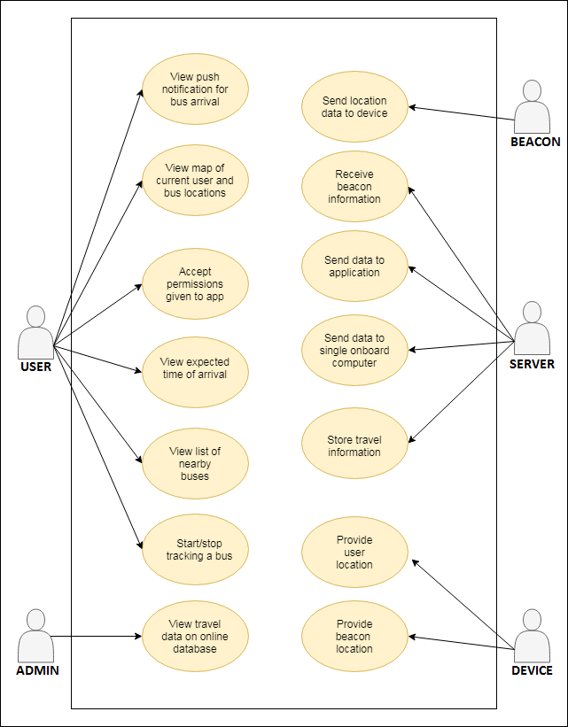

## Technical Specifications

|  |  |  |
| --- | --- | --- |
| Tools/Languages/Libraries | Type | Version |
| Android Studio | Development Environment | 3.2.1 |
| Oreo | Android OS Version | 8 |
| Jenkins/Travis | CI Solution | 2.150 |
| Git | Version Control System | N/A |
| Github | Version Control Hosting Service | N/A |
| MongoDB | NoSQL database | 4.0 |
| AWS | Cloud Platform | N/A |
| Java | Client side Programming Language | 8 |
| Node.js | Backend Programming Language | 8.1.0 |
| Postman | API debugging and testing tool | 6.5.2 |
| Here Maps Android SDK | Maps API | 3.9 |
| Firebase Cloud Messaging | Cloud Push Notification Service | 7.00 |

## Client Side:

* The client side (android app) will be built with Java and XML using Android studio.
* Here Maps Android SDK will be used for map and showing user and bus location.
* The build tool will be gradle.
* The android app gets UUId from firebase cloud messaging service, beacon id from AWS hosted api
* JUnit and Espresso will be used for the client side testing.

## Server Side:

* The server side will be hosted on a cloud platform (AWS).
* Serverless framework will be used as deployment solution
* Node.js will be used primary backend language and writing REST APIs.
* The response of the REST APIs will be in JSON.
* The cloud database will be MongoDB.
* Mocha will be used for server side testing.
* IBM API Test Connect Test and Monitor will be used for server side automated testing

# Work Breakdown

## Work Breakdown Structure

|  |  |  |  |  |  |  |  |  |
| --- | --- | --- | --- | --- | --- | --- | --- | --- |
| Task List | Owner/Completed | Ini | Kyle | Matt | Trevor | Wasek | Average Estimate (Per person) | Total Actual |
| Learning | All |  |  |  |  |  | 41.6 | 143.5 |
| Android | ✔ | 8 | 13.5 | 20 | 3.5 | 10 | 14.8 | 55 |
| Maps | ✔ |  | 7.5 |  |  | 5 | 3.2 | 12.5 |
| Kontakt.io | ✔ |  | 4 | 12 |  | 5 | 3.8 | 21 |
| CI Tools | ✔ |  |  |  | 5.5 | 12 | 10 | 17.5 |
| AWS/Firebase | ✔ |  |  | 18 | 5 | 3 | 3.2 | 26 |
| Databases | ✔ |  |  |  |  | 3 | 2.6 | 3 |
| Node.js | ✔ |  |  |  | 6.5 | 2 | 4 | 8.5 |
|  |  |  |  |  |  |  |  |  |
| Meetings |  | 13 | 24.5 | 22 | 19 | 36 | 36 | 114.5 |
| Client Communication |  |  | 31.5 |  |  |  | 36 | 31.5 |
| Design | All | Ini | Kye | Trevor | Matt | Wasek | 13.6 | 107.25 |
| Documentation | ✔ | 10 | 16 | 20.75 | 12 | 16 | 9 | 74.75 |
| Paper Prototype | ✔ | 1 |  | 2 | 1 | 1 | 2 | 5 |
| WireFraming | ✔ | 4 | 0.5 | 1 | 1 | 2 | 1.8 | 8.5 |
| MockUp | ✔ | 15 |  | 2 | 1 | 1 | 1.8 | 19 |
|  |  |  |  |  |  |  |  |  |
| Development |  | Ini | Kye | Trevor | Matt | Wasek | 79.5 | 387.5 |
| 1. Maps API | Kyle, Matt |  |  |  |  |  | 10.8 | 58.5 |
| 1.1 Integrate Maps Into GUI | ✔ |  | 22 |  |  | 1 | 4.8 | 23 |
| 1.2 Show Where Bus is Located | ✔ |  | 11.5 |  |  | 5 | 3.8 | 16.5 |
| 1.3 Create backend  representation of data on AWS | ✔ |  |  | 8 |  |  | 8 | 8 |
| 1.4 User location & Map | ✔ |  | 11 |  |  |  | 0 | 11 |
| 2. Kontakt Beacon API | Matt | Ini | Kyle | Trevor | Matt | Wasek | 3 | 4.5 |
| 2.1get location data from  beacons, or arduinos. | ✔ |  |  | 3.5 |  | 1 | 3 | 4.5 |
| 3. Backend - Firebase | Matt | Ini | Kyle | Trevor | Matt | Wasek | 7.5 | 7.5 |
| 3.1 Send trip request to aws | ✔ |  |  | 2 |  |  | 1 | 2 |
| 3.2 Send trip request to  firebase | ✔ |  |  | 1.5 |  |  |  | 1.5 |
| 3.3 Send bus location to app | ✔ |  |  | 2 | 2 |  | 2.5 | 4 |
| 4. Android SDK | Tbd | Ini | Kyle | Trevor | Matt | Wasek | 8.4 | 16 |
| 4.1 Collect GPS Data | ✔ |  | 2 |  |  | 2 | 2.4 | 4 |
| 4.2 Store GPS Data | ✔ |  |  |  |  | 8 | 4 | 8 |
| 4.3 Permissions | ✔ |  | 1 |  |  |  | 1 | 1 |
| 4.4 Push Notification | ✔ |  |  | 3 |  |  | 2 | 3 |
| 5. Backend - AWS | Wasek | Ini | Kyle | Trevor | Matt | Wasek | 13.4 | 99 |
| 5.1 /POST  /buslocation - sends bus location | ✔ |  |  |  |  | 7 | 4 | 7 |
| 5.2 /PATCH  /buslocation/:id - updates bus location once the first record is created. | ✔ |  |  |  |  | 5 | 5 | 5 |
|  | Wasek | Ini | Kyle | Trevor | Matt | Wasek |  |  |
| 5.3 /POST  /triprequest - sends a passenger trip request. | ✔ |  |  | 0.5 |  | 4 | 4 | 4.5 |
| 5.4 /DELETE /triprequest/:id -  cancels a passenger trip request. | ✔ |  |  | 0.5 |  | 4 | 1 | 4.5 |
| 5.5 /GET /buslocation -  returns latest bus location | ✔ |  |  |  |  | 4 | 4 | 4 |
| 5.6 /GET /triprequest -  returns info about bus stops if an user has planned a trip in last 100 mins. | ✔ |  |  |  |  | 4 | 4 | 4 |
| 5.7 /GET  /triprequest/:busstop - returns individual bus stop info, if a passenger has  planned a trip in last 100 mins. | ✔ |  |  |  |  | 4 | 2 | 4 |
| 5.8 /POST /triggers - sends  user location and timestamp to server when they get on the bus | ✔ |  |  | 8 |  | 5.5 | 4 | 13.5 |
| 5.9 /PATCH /triggers/id  - sends user location and timestamp to server when they get off the bus. | ✔ |  |  | 11 |  | 1.5 | 4 | 12.5 |
| 5.10 /GET /bustime/:busstop-  returns latest bus ETA in minutes | ✔ |  |  |  |  | 8 | 4 | 8 |
| 5.11 Configure serverless and  deploy rest apis on AWS.Receive user and bus locations | ✔ |  |  |  |  | 7 | 6 | 7 |
| 5.12 Deploy mongodb on AWS | ✔ |  |  |  |  | 2 | 2 | 2 |
| 5.13 Setup MongoDB and connect  with node | ✔ |  |  |  |  | 4 | 4 | 4 |
| 5.14 Update existing APIs | ✔ |  |  |  |  | 12 | 2 | 12 |
| 5.15 Setup test environment  and Test /POST/Triggers API | ✔ |  |  |  |  | 3 | 3 | 3 |
| 5.16 Set-up/Security | ✔ |  |  |  | 4 |  |  | 4 |
| 6. User Interface | Ini | Ini | Kyle | Trevor | Matt | Wasek | 6 | 37.5 |
| 6.1 Bus Number Button - when  clicked it shows the bus to be tracked and changes the UI. Also triggers and  the exit button to be displayed | ✔ | 3 |  | 1 |  |  | 1.5 | 2 |
| 6.2 Track Button - triggers  “Bus Tracker Activated” to be displayed | ✔ | 2 |  | 1 |  |  | 1.5 | 1 |
| 6.3 ETA selection - | ✔ | 2 | 7.5 |  |  |  |  | 7.5 |
| 6.4 Bus Selection Button | ✔ | 3 |  | 1 |  |  | 1.5 | 2 |
| 6.5 Bus List uses recycler  list | ✔ | 3 |  | 1 |  |  | 1.5 | 2 |
| 6.6 Display expected arrival  time of bus | ✔ |  | 10 |  | 3 |  |  | 13 |
| 7. Integration and Testing | Trevor | Ini | Kyle | Trevor | Matt | Wasek | 32.4 | 164.5 |
| Ci Tools Setup |  |  |  |  | 15 | 1 | 3 | 16 |
| Usability Testing |  |  |  | 1 | 4 | 5 | 4.8 | 10 |
| Documentation | ✔ |  |  | 4 | 10 | 16 | 6.6 | 30 |
| Unit Testing |  | 8 | 1 | 8 | 9 | 10 | 6.4 | 32 |
| Integration Testing |  |  |  | 4 | 4.5 | 8 | 6.6 | 16.5 |
| Acceptance Testing | ✔ |  | 2 | 1 | 1 | 5 | 5 | 9 |
| Code Review |  |  | 8.5 | 38.5 |  |  | 0 | 47 |
| Final Documentation and  Presentation | ✔ |  | 16 | 10 | 19 | 16 | 16 | 61 |
| Total Hours |  | 72 | 190 | 208.25 | 126 | 249 | 186.7 (Per person) | 738 (147.6 per person) |

## 

## Burndown Chart

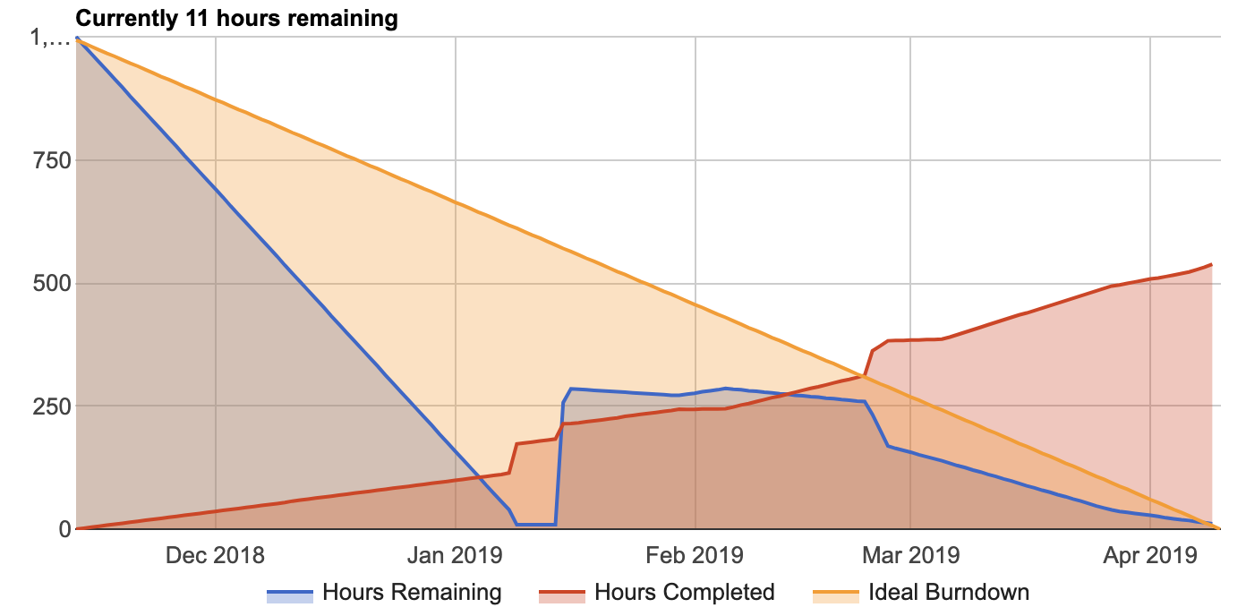

## Team Hours

|  |  |  |  |  |  |
| --- | --- | --- | --- | --- | --- |
|  | Matthew De Leeuw | Kyle Rennie | Trevor Gallicano | Wasek Habib | Ini Oladosu |
| Week 1 | 6 | 6 | 6 | 14.5 | 4.5 |
| Week 2 | 6.5 | 3.5 | 4.5 | 8 | 2.5 |
| Week 3 | 7.75 | 7 | 6 | 9.5 | 6.5 |
| Week 4 | 9 | 7 | 8.5 | 11 | 6.5 |
| Week 5 | 7 | 6 | 7 | 9 | 8 |
| Week 6 | 15.5 | 8 | 11 | 17 | 6 |
| Week 7 | 11 | 8.5 | 9.5 | 12 | 7.75 |
| Week 8 | 11 | 7 | 8 | 10 |  |
| Week 9 | 5 | 7.5 |  | 8 |  |
| Winter Break | 19.5 | 22 | 15 | 28 |  |
| Week 1-2  (New Term) | 11 | 16 | 6 | 12.5 | 8 |
| Week 3-4 | 11 | 10 | 7 | 2 |  |
| Week 5-6 |  |  |  | 24 |  |
| Reading break | 41.5 | 24 | 15.5 | 31.5 | 10 |
| Week 8-9 |  | 13.5 | 6.5 | 16 |  |
| Week 10-End | 47.5 | 42 | 14.5 | 46 | 12.25 |
| TOTAL | 208.25 | 190 | 126 | 249 | 72 |

# Current Implementation

## Test Report

Type of Test Legend:

|  |  |  |
| --- | --- | --- |
| U-Positive Unit Test | I-Integration Test | A-API Test (Integration) |
| S-System Test | M-Manual/User Test |  |

|  |  |  |  |  |
| --- | --- | --- | --- | --- |
| Requirements | Type of Test | Pass (P) or Fail (F) | Developer | Tester |
| Functional Requirements |  | | | |
| User |  | | | |
| User is able to use application on Android device with Android 8 or later. | M | P | N.A. | MD,KR,TG |
| Users are Identified by Instance ID, or mac address. This ID does not change. | U,M | P | N.A. | KR |
| Android Application will ask for user’s permission to access location, and to store information. | M | P | KR | KR |
| Application will be available to all users with no registration. | S,M | P | MD,KR | MD,KR |
| App will let the user track a bus/car. | M | P | KR | KR |
| App will track travel distances and travel times of a user. | U | F | MD | MD |
| Track, Bus Number & Exit buttons are pressable and maintain positions | U | P | IO | IO |
| UI |  | | | |
| Bus Number Button - when clicked it shows the bus to be tracked and changes the UI. Also triggers and the exit button to be displayed | U | P | IO | IO |
| GO button triggers ETA Time Picker | U | P | IO | IO |
|  |  |  |  |  |
| Requirements | Type of Test | Pass (P) or Fail (F) | Developer | Tester |
| ETA Time Picker allows user to select a time for push notification reminder | U,M | P | IO | IO |
| Time Picker is an option wheel | M | P | IO | IO |
| Track button allows user to start tracking a bus | U,M | P | IO | IO |
| Location Services |  | | | |
| Android Application will display a map with the user location. | M | P | KR | KR |
| App will only track the current location of a user while they are viewing the app. | U | P | KR | KR |
| Android Application will display a map with the tracked bus location. | M,I | P | KR | MD |
| Application will display the expected arrival times of the selected bus. | M | P | KR | MD |
| Application will show the 97 bus/car with LTE enabled small board computer with GPS tracker board. | U | F | MD | MD |
| Notifications |  | | | |
| User will be notified when the bus arrives at the selected stop | U | F | MD | MD |
| User will be notified about the wait time for the next arriving bus. | U | P | KR | KR |
| Server |  | | | |
| App will send user location asynchronously to the cloud server if they are tracking a bus/car. | A | P | MD | MD |
| Admins will be able to view data stored in the online database hosted in AWS. | M,U | P | MD | MD |
| Cloud server will perform some computations to check if the user is on the bus. | U | P | MD | MD |
| Cloud server will perform some computations to check if the user is out of the bus. | U | P | MD | MD |
| Requirements | Type of Test | Pass (P) or Fail (F) | Developer | Tester |
| PATCH - Cloud server will store user’s travel distance anonymously in database. | U | P | WH | WH,TG |
| PATCH - Cloud server will store user’s travel time anonymously in database. | U | P | WH | WH,TG |
| DELETE /triprequest/:id so trip request is removed when the user does not wish to track a bus anymore | U | P1 | WH | WH |
| Rest APIs |  | | | |
| Application will send beacon information to the cloud server. | A | P | WH | TG |
| Application will send nearby beacon notification to the server when the user is on the bus. | A | P | WH | WH,TG |
| Application will send user selected bus stop and time reminder to the cloud server. | A | P | WH | TG |
| Application will send travel data to the server | A | P | WH | TG |
| Cloud server will send tracked bus location to the application. | A | P | WH | TG |
| Cloud server will get user location when he/she is in the beacon range of the bus location. | A | P | WH | TG |
| Cloud server will send tracked bus location to an LTE enabled computer at bus stop/bus. | A | P | WH | TG |
| Cloud server will send real time ETA to the android app | A | P | WH | TG |
| GET /triprequest/:busstop Cloud server will send requested bus stop location of the passenger to an LTE enabled computer on the bus. | A | P | WH | TG |
|  | | | | |
| Requirements | Type of Test | Pass (P) or Fail (F) | Notes | |
| Non-Functional Requirements |  | | | |
| Development |  | | | |
| Developed as an Android application written in java. | M,U | P |  | |
| Development process will be completed using the agile method. | M | P |  | |
| Application will use third-party API’s. | M | P |  | |
| Costs for development (such as cloud service or third party API’s) will be covered by the client. | M | P | Total cost of project remains $0.00 | |
| Performance |  | | | |
| User must be connected to the internet. | M | P |  | |
| Software will handle at least 2000 users. | S | F | Test out of scope. See Appendix C-7.3: Out of scope and exceptions | |
| Software will be scalable up to the entire 97 bus route in Kelowna. | M | P | Requires adding locations of other bus stops | |
| Bus position will be updated within 3 seconds (including screen latency). | M,U | P | Position update time determined by implementation of beacons | |
| Application and small board computers use http calls (REST APIs) to communicate with the server. | M | F | See test below | |
| Application and small board computers use https calls (REST APIs) to communicate with the server.* | M | P | Added security over original requirement. | |
| Bus tracking will only show information related to the next bus(es). | M | P |  | |
| App will not track location in the background | M | P |  | |

## User Test Results

We have conducted one round of usability testing. A test version of the app was installed onto 2 Android devices. The application was tested by 25 users; however, it should be noted the proportion of testers who are part of the target audience cannot be determined. The testers were given a walkthrough of the app and were then asked to answer a set of six questions. Our goal was to receive a positive average score for each question (A positive score must be greater than 3: Neutral).

### Q1: I am satisfied with the look and feel of the app.

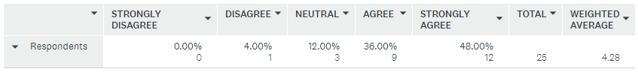

### Q2: The bus location updates in an appropriate time.

### Q3: The interface is responsive to my actions.

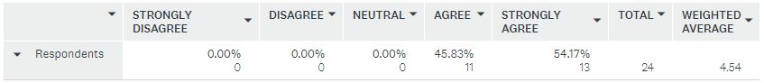

### Q4: All the features are necessary and useful.

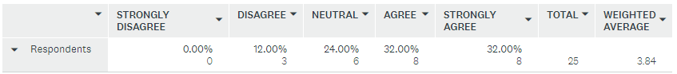

### Q5: I would recommend this app to a friend or colleague.

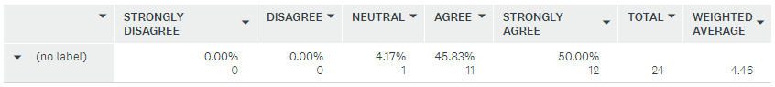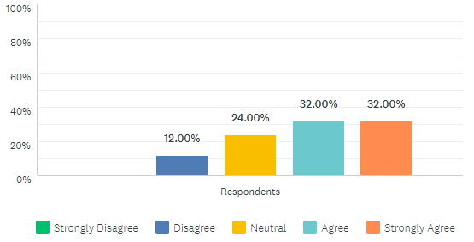

### Q6: Are there any additional features you would like to see added to the app?

* Help boxes or indication of what is happening
* Stylize the UI and design features a bit more
* Add the word minutes to the timer
* Have an option to select a location and see all the buses in the area
* The text for bus number looks [weird] on the side with the curved glass
* A little more UI for easier info
* Making buttons and status more clear. allow trip planning without centering on the bus.
* There isn't much affordance in the interface. Frequently wasn't sure where to go next.
* I would like to see a route when I plan a trip
* One of the testing devices has a screen that is curved on the left side. The application’s UI does not account for such a device.

## User Testing Summary

The application received an average rating above 3 for all questions. This satisfies the minimum requirements we had set out to achieve. While most testers liked the look of the app, some respondents mentioned they found the UI to be unclear and confusing. In response to these concerns we implemented a new UI for the current version of the app. The current version has not undergone usability testing, and a second round of testing would need to be completed before the UI can be deemed deployment ready.

# Design and Testing

Bus Tracking

University Of British Columbia Okanagan

COSC 499

Authors:

|  |  |  |
| --- | --- | --- |
| Document Owner(s) | Role | Contact |
| Wasek Habib | Product Manager | wasek.edu@gmail.com |
| Matthew De Leeuw | Integration Lead | mattdeleeuw@hotmail.com |
| Trevor Gallicano | DevOps Lead | trevorg@hotmail.ca |
| Ini Oladosu | Technical Lead | inioladosu@gmail.com |
| Kyle Rennie | Client Liaison | kyrenzie@gmail.com |

Document History:

|  |  |  |
| --- | --- | --- |
| Version | Date | Document Revision Description |
| 1.0 | November 13, 2018 | Initial document |
| 2.0 | November 20, 2018 | Changes reflecting new project requirements. |
| 3.0 | April 16, 2019 | Revision for final report |

## Usage Scenarios

### User Groups

* University Students
* Retirees
* UBC Staff
* Commuters
* Physically impaired people

### Actors

|  |  |
| --- | --- |
| Actors | Goals |
| User | Select buses to track & receive notifications of the bus’ whereabouts |
| Beacon | Sends information to App |
| Admin | Views the travel data online |
| Server | Stores user travel data, beacon info, and sends and receives notifications |

## System Architecture Diagrams

### Software Architecture

The orange labeled Raspberry Pi and Light Sensor on the bus and Speaker at the bus stop are under engineering teams scope. We are responsible for the blue items, which are the mobile app, server, and beacon on the bus.

Raspberry pi sends real time bus location to the server and the app gets it when needed. The app sends user requested reminder to the server and server sends that request to the raspberry pi. The request contains passenger’s bus stop info. Raspberry pi processes it and passes the info to the light sensor and speaker when required. The server also does some calculations and send that info to the app. The app then sends a push notification to the user. Last but not least, the app receives a trigger from the beacons when the passengers are on and off the bus and sends that info to the server.

## State Diagram

The state is very straightforward. There are two paths you can follow, one where you interact with the app and one where you are exiting the app. The top path, which is the intended path to use the app, follows the basic functionality of the app and what the user would experience as they used the app to track their desired bus. The user accepts permissions, choses which bus they would like to track, then the amount of time before bus arrival, then they are notified when the bus is close to their stop.

## NoSQL Data Model

triprequests:

{"_id":{"$oid":"5cb3c9cb887a69ae074ffc2d"},"stopLocation":{"coordinates":[{"$numberDouble":"-122.5"},{"$numberDouble":"31.7"}],"type":"Point"},"userId":"fes08rweu08we09jdia","tripId":{"$numberInt":"3"},"busId":"fdsf","busStop":"UBCO A","requestedTime":{"$date":{"$numberLong":"1555286475610"}},"reminderTime":{"$numberInt":"12"},"__v":{"$numberInt":"0"}}

triggers:

{"_id":{"$oid":"5cb3c9cc887a6906254ffc2f"},"startLocation":{"coordinates":[{"$numberDouble":"-122.5"},{"$numberDouble":"31.7"}],"type":"Point"},"endLocation":{"type":"Point","coordinates":[]},"completedAt":null,"userId":"fes08rweu08we09jdia","tripId":{"$numberInt":"3"},"beaconTrigger":"testdb6","busId":"97","startedAt":{"$date":{"$numberLong":"1555286476038"}},"__v":{"$numberInt":"0"}}

buslocations:

{"_id":{"$oid":"5c9d578bce7a1b3311c87ef7"},"location":{"coordinates":[{"$numberDouble":"-119.44254166666667"},{"$numberDouble":"49.94468166666667"}],"type":"Point"},"busId":"fdsf","timestamp":{"$date":{"$numberLong":"1553815435882"}},"__v":{"$numberInt":"0"}}

## User Sequence Diagram

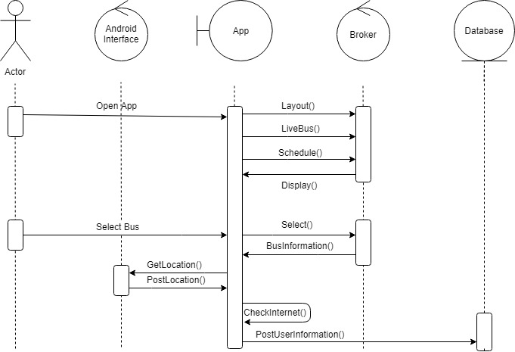

## UI Mockup

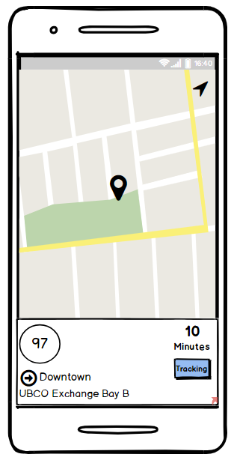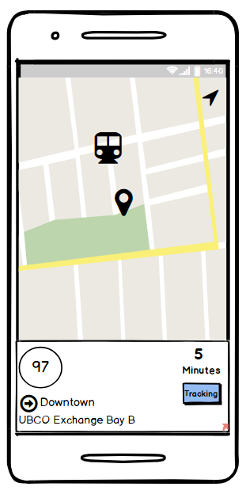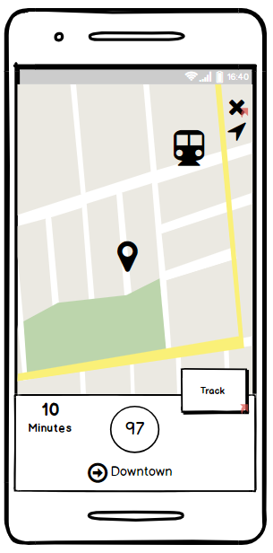

## Detailed Test Plan

This test plan will be used to help the development team meet all requirements in an effective and efficient manner. The plan will outline the test-driven design strategy to be used by the team. Test scope, schedule, examples, and environment will be covered.

### Test Scope

The following tables outline the scope of testing. Functional and non-functional requirements have been separated. Each component has been split into different types of tests. Positive system testing will involve all components, so it has been ignored.

### Functional Scope

|  |  |  |  |
| --- | --- | --- | --- |
| Item | Component | Description | Type of Test |
| FRT_01 | App UI | Verify app displays information to the user. Includes bus location, all screens displayed to the user, and displaying the push notification. | Positive Unit Tests |
| FRT_02 | App UI | Verify information being displayed is correct according to the other components. | Positive Integration Tests |
| FRT_11 | Bus Tracking | Verify app receives information from nearby beacons. | Positive Unit Test |
| FRT_21 | Cloud Server | Verify travel information is stored on the online server. | Positive Unit Test |
| FRT_22 | Cloud Server | Verify server can send data to additional hardware created by the Engineering team. | Positive Unit Test |
| FRT_31 | Data Transfer API | Verify travel information is correctly sent to the cloud database using an api. | Positive Integration |
| FRT_41 | Push Notification | Verify push notification provides correct time estimate. | Positive Unit Test |
| FRT_42 | Push Notification | Verify push notification is only given when the bus has arrived at the stop. | Positive Integration |
| FRT_51 | Regression Testing | Verify app functions after the addition of a new module/feature. | Regression Test |
| FRT_61 | Travel Information Database | Verify travel information is stored on the cloud server. | Positive Unit Test |
| FRT_62 | Travel Information Database | Verify travel information is removed from the device after it has been sent to the server’s database. | Positive Integration Test |
| FRT_63 | Travel Information Database | Verify that faked/broken travel information is excluded from the database. | Negative Unit Test |

### Non-Functional Scope

|  |  |  |  |
| --- | --- | --- | --- |
| Item | Component | Description | Type of Test |
| NRT_01 | Beacon/AppInteraction | Verify app receives information from beacon when it is within the required range. | Positive Stress Test |
| NRT_02 | Beacon/AppInteraction | Verify app is able to receive information from a different beacon as it moves between beacon ranges. | Positive Integration Test |
| NRT_03 | Beacon/AppInteraction | Verify app is stable while out of range of beacons. App does not show false information and does not crash. | Negative System Test |
| NRT_11 | Bus Location Tracking | Verify bus location is accurate within 100m. | Positive Integration Test |
| NRT_12 | Bus Location Tracking | Verify bus location is updated at least once every 3 seconds. | Positive Unit Test |
| NRT_21 | App UI | Verify buses updated location is displayed within the same 3 second interval as test NRT_12. | Positive Integration Test |
| NRT_22 | App UI | Verify app displays information of the selected bus. | Positive Integration Test |
| NRT_22 | App UI | Verify the app’s UI is user friendly. | User Testing |

### Out of Scope and Exclusions

|  |  |
| --- | --- |
| Item | Description |
| Functionality of Additional Hardware | Functionality of any additional hardware outside of beacons and android device will not be involved in integration testing. Such devices are the responsibility of the Engineering team. |
| Number of Users | Stress testing of high number of users is excluded due to logistical limitations. Number of available devices for testing does not approach the required amount for proper testing. |
| Security of Beacon Data | Security for data transfer between beacons is out of scope. Responsibility of testing falls upon Kontakt.io. |
| Performance Req. as Regression Tests | Performance tests will be excluded from regression tests executed by the CI solution. These tests require connection to the physical beacons, which is not possible on an automated testing platform. (Note: Such tests will still be conducted manually) |

### Test Schedule

To accommodate a TDD strategy, three levels of testing will be implemented as follows:

* Unit tests will be used to verify the functionality of single modules. Unit tests will be written as black box tests. Unit tests will be prepared prior to their respective module’s development and are executed upon completion of the module. Defects must be fixed prior to any integration of the module.
* Integration tests will be used to verify functionality between multiple modules. Integration tests will be prepared prior to the integration of two or more modules (and before the development of such modules if possible). Integration tests will be executed after the modules are integrated into the system. Once passed, integration tests will be added to the regression tests. Integration tests will be prepared and executed iteratively to ensure quick location of defects.
* System tests will be prepared prior to development of the application. System tests will begin being executed upon completion of the minimum viable product. Passed system tests will be added to regression tests.

Additional restrictions will be used to accommodate special requirements. These restrictions will be implemented as follows:

* Regression tests contain all previously passed integration and system tests. Key unit tests may also be included. These tests will be continually executed to ensure new features do not degrade code functionality. Regression tests will be executed by the CI solution prior to code deployment. Failed regression tests will stop the deployment of code.
* Stress tests will be used to verify minimum distance requirements are being met. Stress tests will be written and executed as system tests.
* User tests will be conducted manually by allowing users to interact with a working version of the system. Feedback will be gathered about their experience, and the feedback will be used to determine the result of the test. These tests will be created and conducted once a working version of the app is complete and may be redone after a major change to the App’s UI.
* API tests would be used to verify data is being exchanged between cloud server and other devices using standard HTTP protocols. These tests will be created and updated once the REST APIs are written.

### Negative Unit Test

Negative unit tests will be used to test the stored travel data. The user will not directly input any data; however, travel data will be validated after its transfer to cloud database to ensure there is no fake data. The tests will verify that data will be added to the database if and only if it is possible data. As an example, one test will verify that the module can detect that the given bus beacon id is not a valid beacon id.

### Positive Unit Test

An example positive unit test would verify the UI displays the correct screen after the user selects a bus to track.

### Positive Integration Test

An example integration test would have the app send travel information to the server but never receive a reply before the device goes offline. In a successful test the device should retain the information and attempt to send it again the next time the device connects to the server. The app should also not delete the record until it receives a positive response from the server. Success also requires the server to behave appropriately when the data is sent again (i.e. should not insert repeated data into the database).

### Positive System Test

An example system test would have the user select a bus that is about to arrive at their stop, but have the user arrive to the stop after the bus has left. Success for this test would require the app to provide a push notification explaining that the bus was missed, and any other result would be a failure.

### Negative System Test

The app should still function while it not receiving valid data from any beacons. One test would verify the app displaying a push notification while not receiving data from a beacon.

### Regression Test

All regression tests are copies of other previously run tests. An example regression test would verify a UI element is still displayed correctly even after an update to the code.

### User Test

An example UI test would have a test user use the basic functions of the app and have the user rate the usability of the app’s UI. Success would require the user to have no negative opinions of the UI, while the contrary results in a failure.

### Positive Stress Test

Stress tests would be used to verify the requirement for minimum distance to a beacon for the device to receive information. An example test would place the device at required range to the beacon, and verify the device is receiving all of the beacon’s sent data over a long period of time.

### API Test

API tests would be used to verify data is being sent and received from the cloud server to other devices. An example would be verifying bus location data is being sent to the user device and single board computers.

### Test Data

Automated tests that require beacon information will use dummy data as a real connection would not exist to provide real data. This dummy data may include real beacon data taken from previous tests. Additional dummy data may be created to expand allow further testing. Additional data would include impossible/incorrect data and possible data which adds variety to the real collected data. Success of tests should take into account the correctness of the data being used. The data should be maintained in files so that regression tests can be run with consistent inputs.

### Test Environment

To ensure efficiency of testing all developers are expected to be using Android Studio and should be writing with Java 8. In addition, tests should be written in such a way to be used by the following testing tools:

* JUnit – Framework used for constructing unit tests.
* Espresso – Framework used for testing the UI of Android applications.
* Jenkins- CI solution (Tests must be written in Java 8 only).
* Mocha - Test framework for node.js used for server side testing.
* Postman - Tool for verifying API responses.
* IBM Connect Test and Monitor - Tool for automated API tests.

# Future of Project and Summary

## Environment Description

### Workflow

Developers on the project created Trello tasks based on what needed to be done before beginning work. Everyone would then assign the task to themselves and estimate the hours it would take after discussing what needed to be done in a meeting. Developers would create their own branch based on what they were working on. For large features developers would name their branch after the trello task they were assigned. They were encouraged to commit to the branch often so work would be secure and rolled back if required. Once a developer finished work on the feature they would create check to see if their were merge conflicts with the branch being merged into. If there were conflicts they would attempt to solve them by themselves. Afterward a pull request would be created and the integration lead would safely merge the branch into the master branch.

### Testing

On the client-side unit tests would be written before work was done when possible. After a feature would be implemented it would be unit tested to see if it’s working properly. Otherwise, it would be manually tested. For UI components they would be implemented first and then tested using Espresso testing. Jenkins was used to test that the build would compile every night on the master branch. On the server-side API responses were tested using postman. After all API’s were determined to be working they were tested regularly using IBM Connect testing to ensure continued service.

### Deployment

Any additional bus stop locations should be added to the application prior to deployment. This requires a name for each stop as well as the stop’s longitude and latitude. An Android APK can be built from the master branch. The application can then be distributed to users/testers through any desired means (Google Play store, file sharing, ect). Following installation, users can immediately use the app, and the app will automatically connect to the necessary servers. Users will not need to download any additional applications or services in order to use the app. Deployment and use of the app does require the continuous operation of the AWS backend server, Firebase server, and MongoDB database (unless an alternative is developed). These servers run automatically and do not require extensive maintenance.

## Known Bugs

* Each night the bus location will reset to the middle of the ocean as API testing is done
* The application can’t deal with rotation of the phone, it will crash
* Movement of the map to center can be jerky due to lack of animation from HERE maps
* If map is scrolling and the user tries to center on a location it will continue scrolling after being centered (keeps its momentum)

## Key Lessons Learned

* It’s good to be flexible to change in a project
  + Specifically to changes in scope and scope creep
* Automation tools are very useful when used properly
  + Our automation tools weren’t implemented early enough to be as helpful as they could have been
* Learning new technologies takes a large amount of the time
  + A large amount of time in this project was spent learning the technologies we chose to use

## 

## 

## 

## User Manual

### System Overview

#### System Configuration

The bus tracking app runs on any Android device with Android 8 or later. The application requires connection to Internet in order to save data to database. Bluetooth must be enabled in order to obtain information from the beacons. Data saved in the database can be seen using any major Internet browser. After installation on the device, the bus tracking app can be used immediately without any further configuration.

#### User-Access Levels

All users are able to use the application and do not require any account. Travel data can only be viewed by admins.

#### Contingencies

In case of loss of internet connection it is not possible to use the application. Data will be lost in the case of no internet connection, and notifications will not be received. Bus tracking and notifications will still work if only Bluetooth is disabled; however, travel data will not be properly collected if Bluetooth is disabled at any point prior to or during app use.

### Getting Started

#### The Bottom Black Bar

(text view)



This bar shows the bus being tracked in the top left, the stop which you are closest to, and how long till the bus arrives at that stop on the right. Clicking this bar without anything else will display the busses position on the map. After the bus is displayed on the map clicking this bar again will center the map view on the bus location.

#### Navigation Button

(top right)



Pressing this button at any time will center the map view on the users position.

#### Notification Button



If the bus isn’t being tracked the button on the bottom right will look like this. Clicking this will show the bus on the map if it isn’t already showing and bring up a dialogue box asking you how long before your bus arrives at your stop do you want to be notified.

#### Cancel Tracking Button

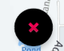

The button on the bottom right looks like this if you have requested to be notified of a bus arrival time. If you want to cancel the notification you can press this button and the bus will stop being displayed.

#### Android Button Bar



To leave the app you may use any of these three, but they all have seperate uses. After you have left the app you may close it by bringing up active apps with the box on the right and then dragging the bus app off the right side of the screen.

#### App Icon

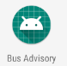

To open the app locate this icon in your app folders and press it.

### Using the System

A user would begin by opening the app with the Application Icon shortcut. Once the app opens for the first time it will ask for permissions. When the permissions are accepted a map will display their current location. A user can use this map to see where they are and to locate nearby bus stops indicated by small empty circles. The app assumes the closest stop to them is the one they would want to use for a bus stop so it will show the estimated time of the bus to there. When the user would like to be notified of the bus arrival they can click either the text view bar or the notification button, which will display the bus. If they click the notification button a window will pop up asking them how long before the bus arrives would they like to be notified. They may choose a time and click ok. Now the bus is being tracked and when the bus is in range they will receive a push notification to their phone telling them the bus is arriving in the specified time. They can click the notification or bring the app up and catch their bus.

### Reporting

#### Report Capabilities

The application sends all necessary information to the server. The server stores the current location of each bus (including all test data); current, canceled trip requests; and all travel data from users. Each entry of travel data contains information for time, location, bus id, and whether the user was entering or exiting the bus. A anonymous ID is used to distinguish data between users.

#### Report Procedure

The data described above can be accessed by admins through MongoDB (See Resources for url and login information). An admin must log-in to view the data, and can view/filter all collected data. Data can be found by selecting ClusterDB followed by Collections.

## Application Installation Guide

1. You will need Git installed (we recommend using GitHub Desktop for ease of use) and have a GitHub account. <https://github.com/>
2. Install Android studio, specifically version 3.2.1.
3. Clone the repository to your local machine using Git. (https://github.com/UBCO-COSC499-Winter-2018-Term-1-2/project-12-bus-advisory-offline-real-time-bus-location-tracker)
4. Open Android studio and select “Open an existing Android Studio project”, then locate where your repository was created and select development in the repository. Click OK.
5. This is where all future client-side work can be done. All code can be found under MapActivity.java which is located in app>src>java
6. To start the emulator and see the application in use click the run button 
7. Click “Create New Virtual Device”, you may choose any device you wish, but for the sake of ease we recommend the Nexus 5 or Pixel 2. Click Next after having the device selected
8. For a system image click download on Oreo with API level 26 and on Android 8.0. When the download is complete click next.
9. You may now choose to name your emulator under AVD Name and make sure the orientation is in portrait.
10. Now when you press run it will display the emulator you created, so select it and hit OK
11. The emulator will work as a real phone would, however it will not get correct GPS location from an emulator.
12. To change location in the emulator click the … on the right side white bar. Under Location in the box that comes up you can change the values of latitude and longitude.
13. The ETA and closest bus stop only work when the bus is in a location on land so it will likely have to be moved as the testing resets its position every night.
14. To install the application on a real device you will have to turn on USB Debugging under developer options on the device. Connect the device to your computer with Debugging enabled and when you click the run button the device should be shown in the list to install to.

## Server-side Installation and Deployment Guide

The server side is built with node.js and uses npm and serverless framework.

1. Install serverless globally- $ npm install serverless -g
2. Configure AWS credentials
3. Go to development/rest-apis using terminal
4. Install all packages- $ npm install
5. Run the server locally- sls offline -c
6. Deploy - sls deploy

## Unfinished Testing

Although all core requirements have been tested there is still some testing that has not been completed:

* Delete API has been tested using Postman but has not been added to the automated tests, so it should be tested again prior to deployment
  + API tests should be updated to stop moving the test bus to the ocean
* Jenkins builds the master branch daily. This should be updated to build and test after a pull request is made to master.
* A second run of user testing should be done to verify the usability of the updated UI.

## Core Requirements Delivered

* Application is available to all users without registration.
* Track a bus/car.
* Display a map with user location.
* Create a server to handle processing and data
* Share information between Raspberry Pi and Android app.

## 

## Unimplemented Features

* User will receive a push notification when the selected bus has arrived at the stop.
  + Push notification is not sent automatically, but push notifications manually sent work as intended
* App will track travel distances and travel times of a user.
  + App does not store travel data. Travel data is instead sent straight to the server
* Software will handle at least 2000 users.
  + Requirement cannot be tested

## Resources

### GitHub Repository

Location: https://github.com/UBCO-COSC499-Winter-2018-Term-1-2/project-12-bus-advisory-offline-real-time-bus-location-tracker

Description: Private GitHub repository containing all up-to date code and documentation.

### API Documentation

Location: https://docs.google.com/document/d/12QO34SncpFbj08Qc4KUrUzaNMPt20GCNRn9pyykwJ5E/edit?usp=sharing

Description: Documentation for design of API’s as well as example requests and responses.

### MongoDB

Location <https://cloud.mongodb.com/user?_ga=2.89485019.1106248769.1553027188-1298984703.1553027188#/atlas/login>

ID [ubco.bus.advisory@fremtidmedia.com](mailto:ubco.bus.advisory@fremtidmedia.com)

Password UBCObusadvisory1!

Description Non-relational database storing bus locations, trip requests, and travel data. After logging in select ClusterDB in the ‘Sandbox’ window then select Collections in the top ribbon to view the stored data. Travel data is labeled as ‘triggers’.

### Firebase Server

Location: https://firebase.google.com/

ID: [ubco.bus.advisory@fremtidmedia.com](mailto:ubco.bus.advisory@fremtidmedia.com)

Password: UBCObusadvisory1

Description: Server used for sending out push notifications/reminders

### AWS Backend Server

Location: <https://us-east-1.console.aws.amazon.com/console/home?region=us-east-1>

ID: [ubco.bus.advisory@fremtidmedia.com](mailto:ubco.bus.advisory@fremtidmedia.com)

Password: UBCObusadvisory1

Description: Server where the core APIs are hosted.

### AWS Jenkins Server

Location: <https://us-east-2.console.aws.amazon.com/console/home?region=us-east-2>

ID [ubco.bus.advisory@fremtidmedia.com](mailto:ubco.bus.advisory@fremtidmedia.com)

Password UBCObusadvisory1

Description: AWS EC2 instance hosting jenkins and the fake bus node application (for testing). The instance can be accessed by using ssh to reach:

e2-user@ec2-18-218-198-68.us-east-2.compute.amazonaws.com

With the ppk file (if used on a windows machine). The .ppk file must be converted from the .pem key available in the repository: docs/AWS.

This server can be terminated with no ill-effect on the rest of the project.

### IBM Connect Test and Monitor

Location: <https://ibm-apiconnect.github.io/test-and-monitor/>

ID [ubco.bus.advisory@fremtidmedia.com](mailto:ubco.bus.advisory@fremtidmedia.com)

Password: UBCObusadvisory1

Description: Automated API testing tool currently set to test the APIs once per day.

# Approval

Product Manager:__________________________________

Signature: __________________________________

Project Sponsor:___________________________________

Signature: ___________________________________